Field visit Report / Internship Experience, 16. - 25. November 2016

Hosting organization: Tanzania Association of Social Worersk, TASWO – Kilimanjaro Branch
Sponsor: FO, Hordaland Branch
Submittet by: Mona Ynnesdal & Sylvi T. Hesthamar

Our experience:
21.- 25. November we were trainees at Amani Children's Home, a centre for street children situated in Moshi, Tanzania.
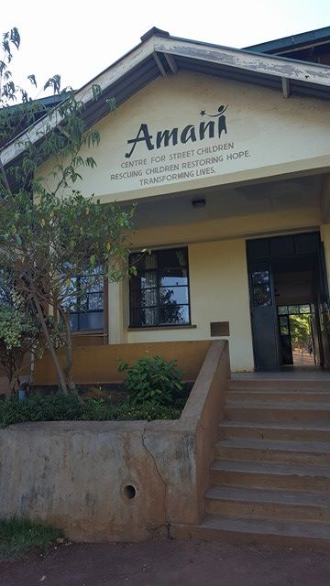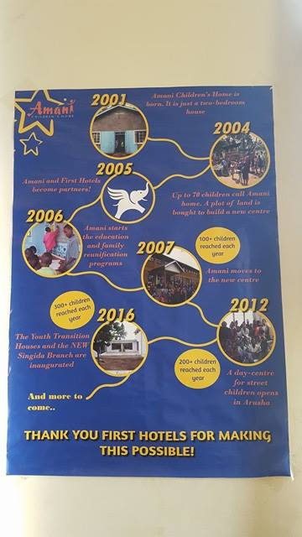
Amani was started in 2001 by Tanzanianas, and has gradually evolved over the years. It¨s now the home for over 60 children, and they do follw-up work with over 350 children. They also have a Drop in center in Arusha, a Transition centre for youth and the do street work in Arusha and Moshi.

At our arrival we got introduced to our contact person Mr. Japhary Salum and we got to meet with the Executive Director, Mr. Meindert Schaap. We got information about the centre, and we were shown around the property. They have one dormitory for boys, and one for girls. They also have different classrooms and a big area outside for the kids to play and to exercice. There are two shifts at the center of social workers. Most people work during the daytime. There are three men and two women from kl.17.00 working until 8.00 in the morning, staying there 4 and 3 days a week. It is a manager and administration who works with funds collection. There are kitchen staff, caretaker and teachers.

At the centre they focus on education, reunification and they always start the kids stay at the centre with an health check (for AIDS and STDs). The children were then tested for what level they wear at school and then placed in the right class. Some of the children had no education before they came to Amani, because the parent could not afford to pay for the school uniform. Amani Center always tried to bring back home the children they found on the street. And help the family and child at their home aria.
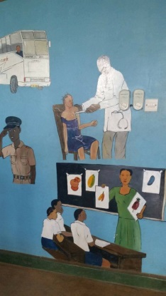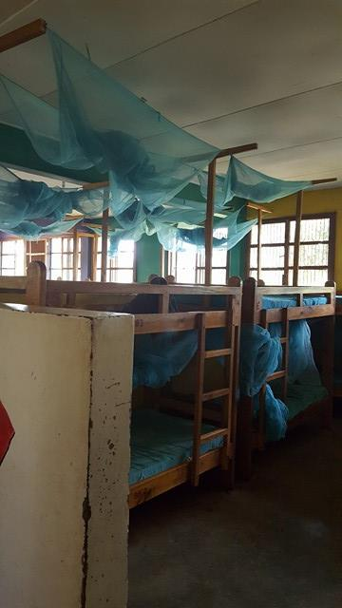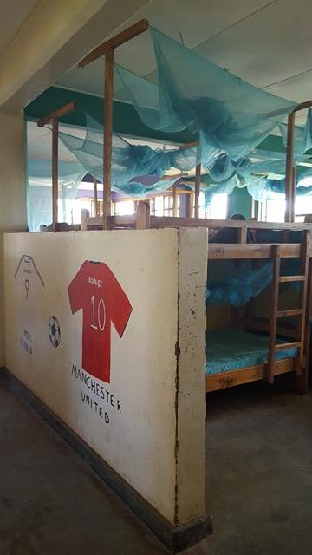
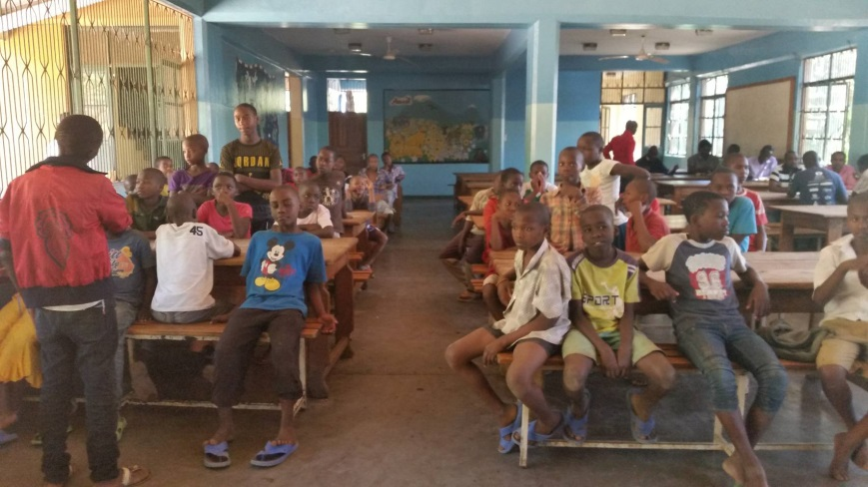

The first day we got to meet all the social workers, and had an interesting meeting where we learned about each others everyday work and shared experiences and challenges.
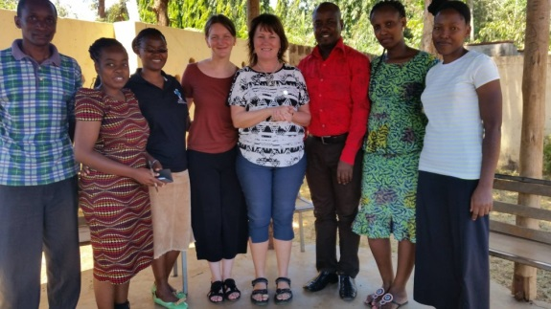

During the week we got to have a conversation with the counceller about her work, we got education about their method of doing street work, and we got to join one of the streetworkers walking the streets of Moshi (in day time).
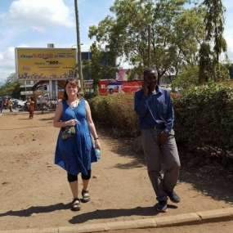
We also got information about the Youth centre that just opened, and we got a tour at the centre. The Youth that live there go either to school or in work related practice. They have all lived in the main center before moving in to the youth center.
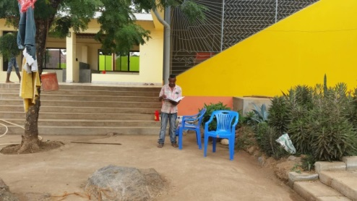

The 25. of November there was a big Christmas party at the Amani centre, and during the week we got to join in the preparations and we got to see the excitement of the kids.

Every day we joined the staff and kids for lunch. The children who lived at the centers had different reasons to be there. Someone was beaten or did not get food at home, while others were subjected to assaults ect. These children therefore escaped into the larger cities to take care of themselves. If a child tells about violence in the family, the social worker asks / investigates with the neighbors or local authorities if this is correct. In some cases, they feel that the child does not speak true.
Some parents shut the child in, others do not give the child food to punishment. Children are often alone because both parents work. The children are experiencing very high poverty. Parents who do not have money for food, electricity, school clothes for the children. Without school clothing the children is not going to school. The family can live in 1 room and there is no room for the oldest child. Some send the children to the Armani Center for schooling.
When the child lives at the Armani Center, they go to school during the daytime. It is a starting class where the child is mapped at what level it is. Some have gone to school while others are illiterate. After the survey, they are placed in the grade that they professionally belong to from the academic levelin
One of the children, whose mother died of AIDS, was by his father closed inside the house because he was different. It turned out that he had poor hearing and was therefore delayed in the development. This boy was placed at the Amani Center by Police and Social Workers.

To show our gratitude we wanted to give something back to the centre. The Amani staff was helpful in *bil og personell, and we went to a second hand marked to buy clothes for the centre – in that way we could support the locals at the marked and the children at the centre. Mona is a COS-P therapist and was teaching the social workers about the Circle of security.
Circle of Security Parenting is a parent-reflection program offering the core components of the evidence-based and internationally acclaimed COS protocol. This 4-Day training teaches professionals to use an eight-chapter DVD to educate parents and caregivers. The program presents video examples of secure and problematic parent/child interaction, healthy options in care giving, and animated graphics designed to clarify principles central to COS. Circle of Security Parenting implements decades of attachment research in an accessible step-by-step process for use in group settings, home visitation, or individual counseling.

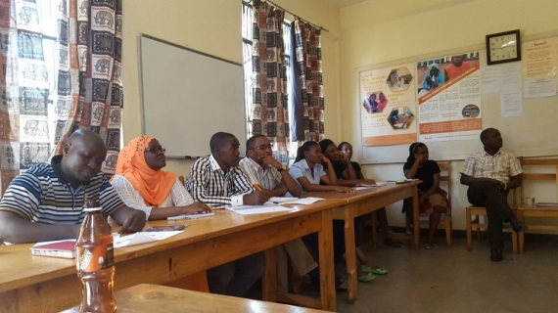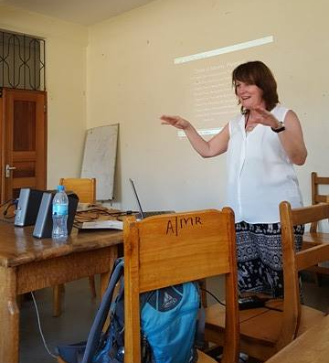

We would like to thank the Amani Center, TASWO and FO Hordaland for giving us a wonderful experience that has both been educational and deeply impressing. We witnessed a lot of good work, and have great faith in the work of grassroot organizations such as the Amani Center. It seemed like many of the children had major connection injuries and had experienced many traumas early in lifte and therefore we think that it would beneficial to the centre to have more caregivers there. But with limited resources it may be difficult. We found that the center utilized the resources they had creatively and that in our profession as social workers we are constantly experiencing insufficient resources. But we can say we were impressed by how many children the center managed to help.
We were also satisfied by the practical arrangements of the trip, and felt safe and attended to during our stay in Moshi.

